
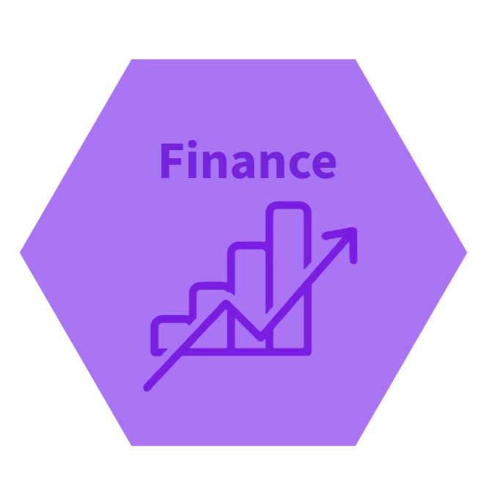
Find Your Fit
What are your top ten things to have from your future job? Use the list on the next page to help you discover your work priorities. Use a highlighter to pick out your top ten, then write them in order of priority below (you could even write your own):
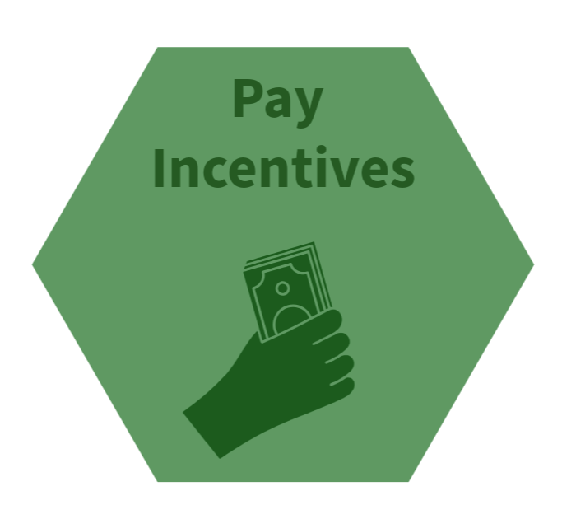
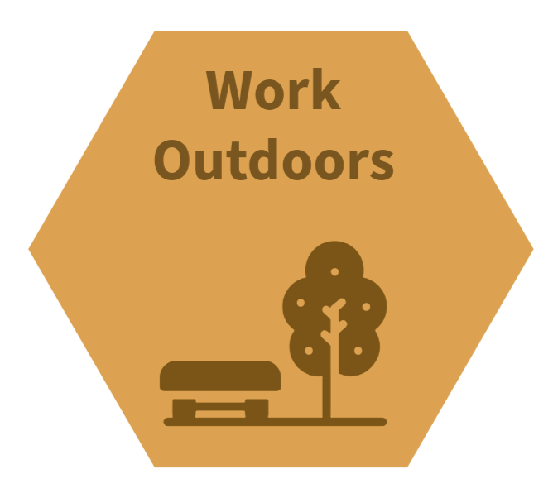
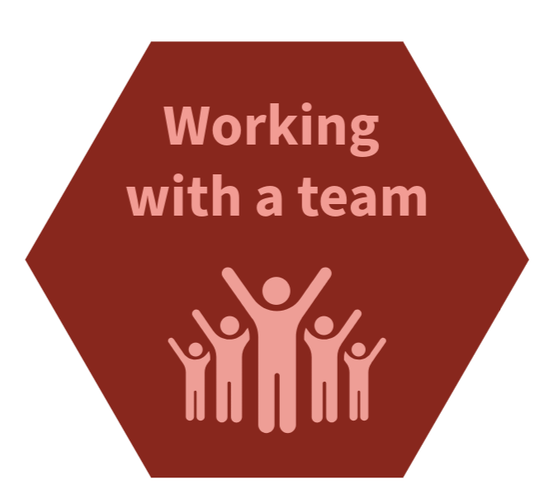
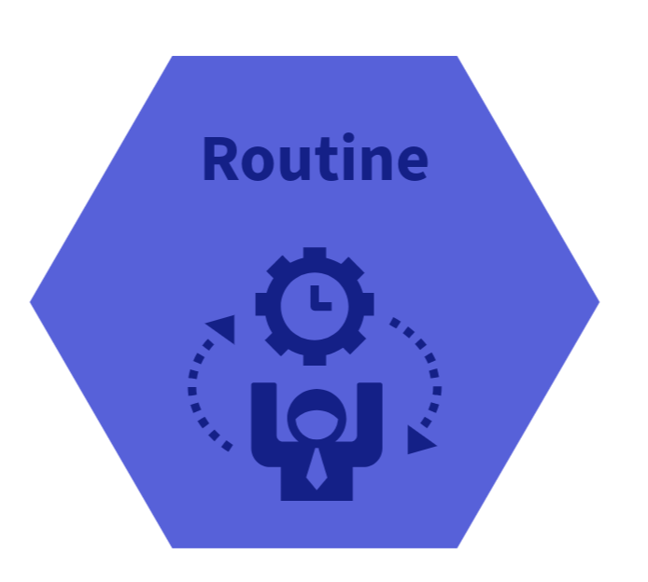
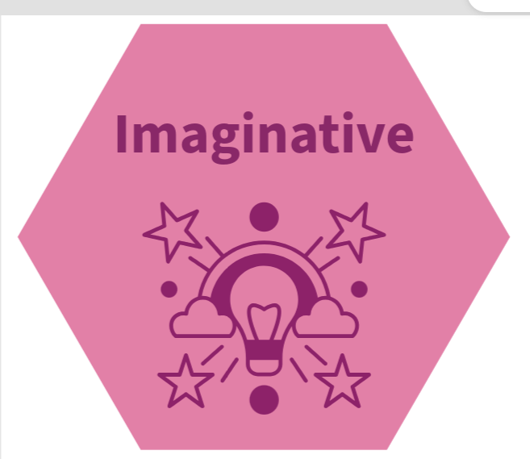
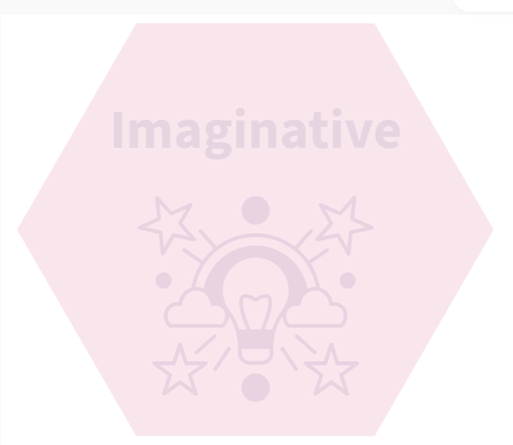
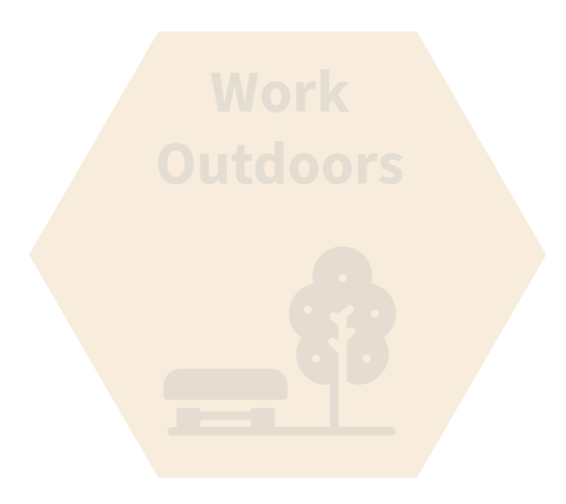
My Top Ten:
Making decisions
Progression
Set Hours
Making things/using your hands
Self-employment
Writing reports and doing research
Working with numbers, data or statistics
Job satisfaction
Location
Fixing things
Providing talks/presenting idea
Work/Life balance
Further learning and qualifications
Praise/thanks for what you do
Company Values
Work that will always be needed
Needing to be physically fit
Work in high risk situations
Working in emergency situations
Influencing others
Working with the public/customer services
Problem solving
Length of commute/travel to work
Company reputation
Working with young people
Working with the vulnerable (children or adults)
Promoting a brand
Earnings
Job security
Being Challenged
Working Conditions
High Status
Being innovative/imaginative
Having a good boss
Great employment benefits
Colleagues you like and trust
Working as part of a big team
Working as a part of a smaller team
Working independently
Helping others
Pay incentives
Having a say in the company/business
Working to goals and targets
Working under pressure
Working evenings and weekends
Working indoors
Working outdoors
Flexible working options (time/place)
Travel
Using IT and/or AI
Work involving sales
Being a team leader/management
Routine
Variety
Being artistically creative
Besides money, most people are looking for work they are likely to enjoy, but what does that mean? Everyone’s wants and needs are different and we all have different priorities. Below there are over 50 different things that can be found in the world of work. There are many more and these are just some examples:

